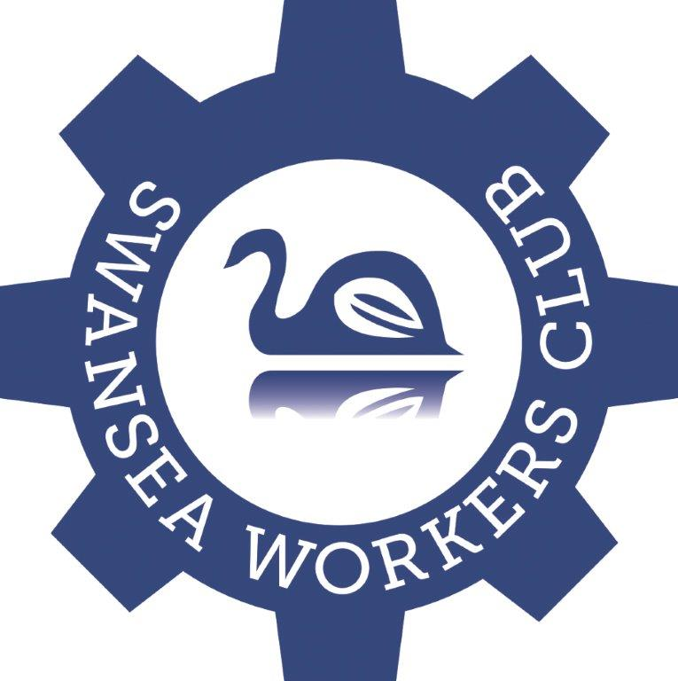

26/02/2016

Dear Sir/Madam

We wish to announce our Swansea Workers Club Young Achiever Program

The Purpose of our program is to acknowledge, encourage and promote the positive achievements in our community by our young sports people, aged between the ages 12-18.

By running this program we wish to

- Provide positive Role Models & Mentors in our youth by highlighting their achievements.
- Educate our surrounding community with examples of their sporting abilities and achievements.
- Build self-confidence and esteem through rewarding these individuals.
- Encourage these individuals in their chosen sport.
- Acknowledge and highlight their achievements
- Develop leadership and life skills to use throughout their future life.

Once a month, our Board of Directors will choose a nominee and reward this person with a family voucher (2 Adults, 2 Children) to dine at our All you can Eat Buffet on a Saturday Night.

This Nominee will also go into a selection process for our Major Junior Sports person Awards Night for the chance to win a $1000 first prize or Runner up prize of $400. This selection process will be held over a 12 month period, so all up we will have 12 nominees to be eligible for selection to win the Major Prize.

Terms and Conditions.

- Nomination must be completed on the official application forms.
- Nominations must address the criteria. This information must be relevant to current 12 months. 1st July 2015-30th June 2016
- Provide a clear photograph in Nomination form
- Finalists are required to attend the Major Award night.
- Nominations need to hand in an application form before the 2nd Monday of each Month.
- Previous winners are ineligible to enter more than once in a 12 month period.
- Entry is free and open to individuals not older than by 18years by close of nominations on the 30th of each month 28th for February.
- Swansea Workers Club Directors will select 2 recipients of the Awards Night ‘Winner & Runner Up’. The Directors decision is final and no further correspondence will be entered into.
- Nominees have to represent a Local Community Group within the 5km Radius of the Swansea Workers Club.
- Entrants must agree to local marketing and media publicity produced by Swansea Workers Club.
- LTPM/14/01187

Our 12 months will start on 1st July 2015 and end on 30th June 2016. If you have any further questions please feel free to contact me on the email address below or club phone number (02) 4971 1377

Nomination Forms are available at the club or on our website http://www.swanseaworkersclub.com.au/ and can be handed in by person or emailed to
melissa@swanseaworkersclub.com.au

Kind Regards
Melissa Burge

Operations Manager
Swansea Workers Club.

